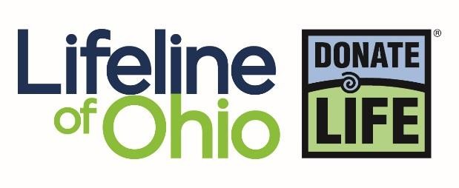

Sample Newsletter Articles
Want to share the message of organ, eye and tissue donation in your next newsletter? These sample articles are easy to customize and use in your next issue to encourage your readers to register as donors.
Option 1
[Company/Organization] Offers Associates the Opportunity to be Heroes:
If offered the opportunity to be a hero, how many people would turn down the chance? Not many, we’re guessing. But what kind of hero are we talking about? One that leaps across tall buildings in a single bound or is faster than a speeding bullet? One that runs into a burning building or jumps into a raging river?
The type of hero we’re referring to is an ordinary person who can make an extraordinary difference by saving or enhancing more than 75 lives. How is that possible? Simply by registering to become an organ, eye and tissue donor and providing the gift of life.
We have joined more than 12,000 companies, associations and government agencies across the United States that are part of the Workplace Partnership for Life. The Workplace Partnership for Life is an important national initiative, developed by the U.S. Department of Health and Human Services, and coordinated locally by Lifeline of Ohio. They encourage companies like ours to share information about donation with its associates.
There are nearly 107,000 men, women and children in the United States waiting for an organ transplant. Tragically, approximately 20 Americans die each day due to the lack of available organs.
Learning more about donation is the first step in becoming a hero. Log onto www.donatelifewv.org to gather more information about donation and to register your donation decision. After you register, be sure to share your decision with your family.
All registered donors offer hope to the thousands who are waiting for their second chance at life. Consider what you can make possible as a hero of donation and register today!

Option 2
[Organization] encourages you to share the gift of life:
This year, [Organization name] has partnered with Donate Life West Virginia to help save lives by educating our community members about the importance of organ, eye and tissue donation, and increasing the number of registered donors. Sadly, nearly 107,000 Americans are waiting for a life-saving organ transplant and more than 500 of them are from West Virginia. This national health crisis is something that our organization is committed to changing. [Name], [Title] of [Organization], encourages you to join them in support of this cause by registering today.
“The need is real and occurring in our very own community,” said [last name]. “It’s time for our community to understand the donation process, share the facts and make educated decisions to provide a second chance for thousands of people and their families each year.”
[If applicable, insert details about upcoming event(s) or activities to promote donation at your organization].
For more information on how you can register or to learn more about donation visit www.donatelifewv.org.

