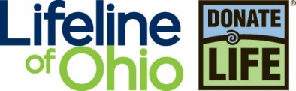
Organ Donation and Transplantation
I CAN…
- Describe why a person might need an organ or tissue transplant.
- Explain why there are not enough organs available to save every person who needs a transplant.
- List the organs and tissues which are most often transplanted.
- Compare and contrast living donation and deceased donation.
- Explain the purpose of the Ohio Donor Registry
- Explain how to join the Ohio Donor Registry, and to amend my decision.

From Dialysis to Dancing
This reading selection was written by high school senior, DaMia Williams, kidney recipient

In the blink of an eye, I went from dancing to dialysis. And I was just 13 years old.

At this time, I went from being a typical teenager to my health taking a drastic downturn. I had constant vomiting, loss of energy and just wasn’t myself. Doctors gave me several diagnosis, but nothing ever quite worked to make me feel better.

Finally after months of not feeling well, my doctor sent me for a blood draw. My mom and I went, got my blood drawn and then she dropped me off at my dance class. I am happiest when I dance – it’s been my passion since I was three.

However, that day, I wasn’t at practice long. Soon after she dropped me off, my mom came in and told me my doctor called and I had to go to the hospital. She asked the doctor if it could wait until after dance, but the doctor was very stern – I had to get to the hospital immediately. I remember getting in the car and asking my mom, “Did my kidneys fail?” I have no idea why I asked that question. As she drove to the hospital, we held hands and prayed.

I soon learned I was in renal failure – my kidneys were only functioning at 5%. Doctors were baffled seeing as how I was still in school and dancing. They thought I was homeschooled based on my kidney function!

After a series of surgeries, I was placed on dialysis and my wait for a new kidney began. Hearing I would need a transplant was confusing for me. I didn’t really know what that meant. My mom was very worried, she knew without a living donor that we would have a long wait ahead of us. My best friend’s mom, my Girl Scout troop leader and a few teachers were tested to be living donors, but unfortunately nothing panned out. I was going to have to wait for a deceased donor to become available.

After a while, being on the waitlist soon became second nature. While it was hard to be hooked up to a machine for so long during dialysis, I got used to it. The hardest part was not being able to hang out with my friends.

And then, on May 20, I got the call! My mom and I were watching my brother’s basketball tournament and we were on a break between games. My mom received a call, but didn’t answer. When they called back again she answered and I heard her say, “we’re on the way right now.” I was so happy, but in shock!

We got to the hospital as quickly as we could and I was prepped for surgery. The last thing I remember is thanking the operating team for doing my surgery before the anesthesia kicked in.

Immediately after surgery, I began to feel better! My doctor said it was the perfect kidney for me.

Six-months after my transplant I received a letter from my donor family. I learned my donor was a dancer, just like me! I also learned she began dancing at the age of three – also just like me! Upon receiving the letter, my family wrote back to express our appreciation, love and gratitude.

My donor is now dancing with me through her most generous gift – won’t you consider registering as an organ, eye and tissue donor? You have the ability to give someone their life back – as my donor did for me.

- What activities would you miss if you no longer had any energy and had to be in bed from 8:00 pm to 6:00 am for dialysis? Describe how this would change your life.

The words listed below will appear in bold print in the reading following elections to aid you in understanding the donation process.
Vocabulary
Amend: (v) to change or modify. (Derivative: amendment)
Allocate: (v) to distribute; to determine who might receive an organ. (Derivative: allocation)
Authorize: (v) to give permission. (Derivative: authorized, authorization)
Deceased: (adj) recently dead.
Donate: (v) to make a gift; to give without expectation of receiving something in return. (Derivatives: donor, donation)
Fatal: (adj) causing death. (Derivative: fatality)
Pediatric: (adj) related to care and development of babies and children.
Recipient: (n) one who receives, or gets a transplanted organ or tissue.
Registry: (n) a written record. (Derivative: register, registration)
Recover: (v) to save from loss and restore to usefulness. (Derivative: recovery)
Transplant: (v) to move an organ or tissue from one person to another. (Derivative: transplantation)
Trauma: (n) physical injury (such as a wound). (Derivative: traumatic)
Viable: (adj) capable of living. (Derivative: viability)
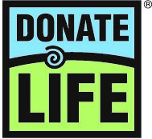 Organ, Eye, and Tissue Donation Saves and Heals Lives
Organ, eye and tissue donation is the process of giving an organ and/or tissues, for the purpose of transplantation to another person. Transplanted organs replace a failing organ and save a life. Organ donation is the gift of life. Tissues are used to replace damaged tissue, or as healing therapies, which restore health, mobility and function. The gifts from organ, eye and tissue donors allow recipients to live fuller, more meaningful lives.

In the United States, over 112,000 people are waiting for a life-saving organ transplant. Last year over 39,000 organ transplants were performed. The only hope for those waiting is to receive the gift of an organ from another person. Every day, 20 people die because an organ for transplant was not available in time. More than 1.7 million patients receive a tissue transplant each year in the US alone. Last year, over 85,000 people received the gift of sight through corneal transplant. So many people are touched by donation. Their healing depends on the generosity of a donor. A single hero who chooses donation might save eight lives through organ donation, heal more than 50 people through tissue donation and restore sight to two people!
Deceased Donation
Deceased donation is the process of donating organs and/or tissues shortly after death. In order for a person to become an organ donor, blood and oxygen must flow through the organs until the time of recovery to ensure viability. This means that a donor is a person who died under circumstances that have resulted in a fatal brain injury, often from trauma (physical injury), stroke, aneurysm or hemorrhage (bleeding or blockage within the blood vessels in the brain) or lack of oxygen to the brain. Only about one percent of deaths occur in a way in which organ donation is possible. This is the challenge which results in a scarcity of organs for transplant.
The Process
Doctors will exhaust all possible efforts to save their patient’s life. Organ donation is only possible, if tests determine that the patient has experienced an unsurvivable brain injury, or if brain death has been declared. Tissue donation is a possibility regardless of the cause of death.
The state and national Donate Life Registries are searched to determine if the patient has personally authorized donation. A person’s registry status instructs the patient’s family and medical caregivers to facilitate the process of organ, eye, and tissue donation. If the potential donor is not found in either registry, his or her legal next of kin is offered the opportunity to authorize the donation.
Once the donation decision is made, the family is asked to give a medical and social history. Knowing the patient’s history is important to ensure the recipient’s safety. Donation and transplantation professionals determine which organs can be transplanted and to which patients on the national transplant waiting list. This process is called allocation.
The matching or allocation process takes place while the potential donor is in the hospital. With over 112,000 patients waiting for a transplant, a process to fairly allocate organs is used. Organs cannot be stored for use later. After an organ is recovered, it is immediately transported to the recipient who is typically in another hospital. After recovery, organs are only viable for a few hours. This means the location of the possible recipient must be close enough to the donor. In addition, the patient and recipient must have compatible blood types.
Body size is also an important factor. An organ that is too small may not be strong enough to sustain the patient. Finally, organs are allocated to the sickest patient first.
Once matches have been found, surgery to recover the organs which will be donated takes place. This surgery occurs in a hospital operating room. When surgery has been completed, the donor’s body will be transported to the funeral home of the family’s choice.
- Is it possible for a person to be and organ, eye and/or tissue donor if they are not listed on their state or national Donor Registry? Highlight or copy the sentence where you located the answer to this question.

- List the five steps in the recovery process. (Look for action verbs as clues.)
  - ________________________________________________________________________
  - ________________________________________________________________________
  - ________________________________________________________________________
  - ________________________________________________________________________
  - ________________________________________________________________________
- List four factors that are considered in the matching process (Finding the right recipient for a donor organ.)
  - __________________________________________________________________
  - __________________________________________________________________
  - __________________________________________________________________
  - __________________________________________________________________

Frequently Asked Questions About Donation
Can a person be too old or too young to donate?
You are never too old or too young to donate. The oldest organ donor was 92 years old! A 107 year old was able to donate corneas in 2016. Organ donation is based on the function of the organ, not the age.

What if my religion does not support donation?
You might be surprised to know that all major religions in the U.S. support donation. If you want more information, go to https://lifelineofohio.org/faith/ to see what your religion says about donation.

Will my family have to pay more if I am a donor?
There is no cost for donation. The organ or tissue recovery agency assumes the costs related to donation.

Will my family be able have the type of funeral they want?
Your family can plan the same funeral arrangements they would make without donation, including an open casket funeral.

If I am a registered donor, will doctors try as hard to save my life?
Lifeline of Ohio, the recovery agency that serves your area, works with 78 hospitals, of which only two perform organ transplants. Transplant doctors only work with patients who need an organ transplant, they would not be caring for you if you came in to the hospital in an emergency situation. The doctors that care for people in emergencies measure their success in lives saved. They will do everything they can to try to save you- that’s what they vowed to do and that’s what makes them look good!

What Can Be Donated
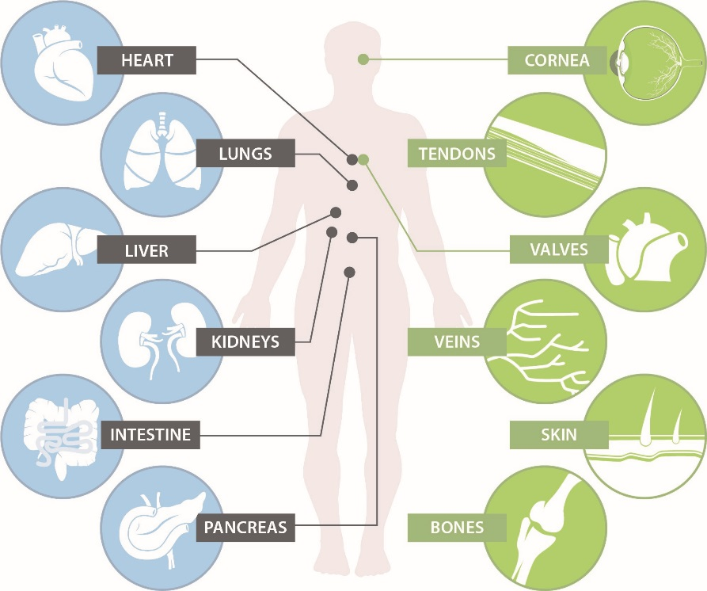

Cornea Transplant
The cornea is the outermost covering of the eye. It is a clear protective layer- kind of like the windshield of your eye. The cornea may be damaged by a disease that weakens it or changes its shape, or it may be damaged by some sort of accident. When the cornea is damaged, it distorts vision in a way that cannot be corrected by glasses. The only way to improve that person’s vision, is to replace the tissue with a cornea from a donor. The transplanted tissue looks like a clear contact lens. The donor doesn’t have to have great vision, just a healthy cornea, because most vision problems are related to other parts of the eye. A single donor, may restore sight to two people. Over 85,000 people in the U.S. had their sight restored last year through corneal transplant.
Organ Function and Common Reasons for a Needed Transplant
Organ | Function | Common Diagnoses
Heart | Pumps blood throughout the body | Cardiomyopathy, coronary artery disease, heart valve defects
Lungs | Removes oxygen from the air we breathe and transfers it to our blood where it can be sent to our cells. The lungs also remove carbon dioxide, which we exhale. | Cystic fibrosis, pulmonary hypertension (high blood pressure in the lungs), chronic obstructive pulmonary disease (COPD), emphysema
Liver | Breaks down and removes harmful chemicals in the blood, produces bile and blood-clotting proteins | Biliary atresia, hepatitis B and C, fatty liver disease, Wilson’s disease, hemochromatosis
Pancreas | Produces insulin and glucagon to regulate blood sugar levels. Produces digestive enzymes to help break down food. | Diabetes which is not controlled by standard treatment, severe kidney damage
Small Intestine | Digests food and absorbs nutrients and minerals into the bloodstream | Crohn’s Disease, trauma, tumor
Kidneys | Removes waste and excess fluids from the body | Diabetes, uncontrolled high blood pressure, polycystic kidney disease

2019 Transplants by Organ Type
Directions: Complete the table below, by calculating the percent each organ represents. (Hint: Find the total transplants first.)
Organ | Transplants | Percent
Kidney | 23,401
Liver | 8,896
Heart | 3,551
Lung | 2,714
Kidney and Pancreas | 872
Pancreas | 143
Intestine | 81
Heart and Lung | 45
TOTAL Transplants |  | 100%

Tissue Transplant

Tissue Type | Typical Use | Benefit for Recipient
Cornea | Replaces damaged or diseased cornea | Prevents blindness; restores sight
Bone | Reconstruction related to trauma, tumors, degenerative diseases | Prevents the need for amputation; accelerates, promotes and allows healing; restores mobility
Skin | Temporary biological bandages for burns- prevents heat and fluid loss,  and reduces scarring | Promotes healing; natural barrier to infection, decreases pain
Valves and Blood Vessels | Repairs congenital abnormalities,  used for heart bypass surgery | Maintains unidirectional flow of blood in the heart
Tendons and Ligaments | Reconstruction related to trauma,  tears, or overuse | Rebuilds joints; restores mobility
Nerves | Restore function when a large segment of nerve is damaged, usually due to trauma | Restores function and feeling
Fascia | ACL repair, shoulder reconstruction,  bladder sling | Restores function and mobility,  Suspends the bladder in normal position

5. Name the following tissues. Use the words in the box.
Nerve Cornea Fascia Blood Vessels
Ligament Tendon Skin Bone

a. thin, fibrous tissue that covers a muscle
b. clear protective covering of the eye
c. a fiber which transmits information to and from the brain
d. thin layer of tissue covering the outside of the body
e. hard, white tissue making up the skeleton
f. tough, flexible tissue which connects bone to bone
g. flexible, inelastic tissue which connects bone to muscle
________________________h. tubes which carry blood through organs and tissues
The Ohio Donor Registry
Although donation is an end-of-life decision, it is a decision that should be considered and made before tragedy strikes. Registering in the Ohio Donor Registry means that upon your death, you agree to become an organ, eye and tissue donor for any purpose authorized by law. That means you could potentially save eight lives through organ donation and heal more than 50 through tissue donation.

The Ohio Donor Registry is the state database that was established by the Ohio State Legislature in 2002 to ensure that an individual’s decision to be a donor is known, documented, and carried out. Talking to your family about your desire to be an organ, eye and tissue donor will make them more comfortable with your decision.

Three Easy Ways to Register:
  - Register online at www.lifelineofohio.org
  - Fill out and mail in an Ohio Donor Registry Enrollment Form (available at all BMV locations or by calling Lifeline of Ohio at 800-525-5667)
  - Say “Yes” to organ donation when you visit the Ohio BMV to receive or renew your driver license, permit or state identification card.
Talk to your family!
Teenagers 15 ½ –17 years old may register their intent to be an organ, eye and tissue donor. You will be asked if you would like to be an organ donor when you register for your driver’s license, permit or state identification card. However, until you are 18 years old, a parent or legal guardian makes a final donation decision. A parent or legal guardian must authorize donation of organs, eyes and/or tissue for anyone under the age of 18. Therefore, it is important to speak with your family about your decision. Once you turn 18, your decision to be a donor becomes legally binding and it cannot be changed by your family.
The tragic circumstances which often accompany donation are no time for families to be surprised or confused about their loved one’s final wishes. By discussing your decision, you are helping your family communicate clearly and honestly about a potentially life-changing decision.

Test Your Knowledge
- All organ donors have experienced a death related to a brain injury. Name three different types of brain injury.

- Explain how a single donor might save eight lives.

- Why do you think there are not enough organs for transplant to save those people who are waiting? Support your answer.

- Would a cornea transplant change the color of the recipient’s eye? Explain your reasoning.

- Why do you think it is important to talk with your family about your decision to be an organ donor?

If you have any questions related to donation that weren’t answered here,
please contact us at www.lifelineofohio.org.

